Infosys Spring Board Virtual Internship – 6.0

Project Title:

AI/ML-Based Personalized Diet Plan Generator from Medical Report – Group 2

B. Indira Priyadarshini

Milestone 1: Collection and Pre-processing of Medical Report Datasets

1. Objective
The objective of this milestone is to collect medical report datasets in multiple formats and extract meaningful structured information from them.
This step forms the foundation of the project by enabling the system to understand and process raw medical data required for generating personalized diet plans.

2. Problem Statement
Medical reports are available in heterogeneous formats such as:
- PDF documents (digital and scanned)
- CSV files containing numerical health parameters
- Plain text files
- Scanned images of prescriptions or reports
These formats make it difficult to directly extract and analyze patient health information.
Hence, there is a need for a robust data collection and preprocessing pipeline capable of:
- Handling different file formats
- Applying OCR for scanned documents
- Extracting both numeric health parameters and doctor’s notes

3. Dataset Collection
The datasets were collected in the following formats:
Format | Description
PDF | Digital medical reports and scanned prescriptions
CSV | Tabular medical data (e.g., blood sugar, cholesterol values)
Text (.txt) | Text-based medical summaries
Scanned Images | Images of handwritten or printed medical reports
These datasets simulate real-world medical reports commonly used in hospitals and clinics.

4. Methodology
The overall methodology followed in this milestone is shown below:
- Input file detection based on file extension
- PDF classification into:
  - Digital PDF
  - Scanned PDF
- Text extraction using:
  - PDF text extraction (pdfplumber)
  - OCR for scanned PDFs and images (Tesseract OCR)
- Structured data extraction:
  - Numeric health parameters using Regular Expressions
  - Doctor’s notes using NLP techniques
- Output generation in structured CSV format

5. Tools and Technologies Used
- Programming Language: Python
- OCR Engine: Tesseract OCR
- Libraries:
  - pdfplumber – Digital PDF text extraction
  - pdf2image – Convert scanned PDFs to images
  - pytesseract – OCR processing
  - OpenCV & Pillow – Image handling
  - Pandas & NumPy – Data processing
  - SpaCy – Natural Language Processing

6. Implementation Details
6.1 PDF Type Detection
- The system checks whether a PDF contains extractable text.
- If no text is found, it is classified as a scanned PDF.
6.2 Text Extraction
- Digital PDFs: Extracted using pdfplumber
- Scanned PDFs: Converted into images and processed using OCR
- Images: OCR applied directly
- CSV Files: Loaded using Pandas and treated as textual data
- Text Files: Read directly using file I/O

6.3 Numeric Data Extraction
Key health parameters extracted include:
- Blood Sugar
- Cholesterol
- BMI
- Blood Pressure
- Hemoglobin
Regular expressions were used to identify and extract numeric values accurately from unstructured medical text.

6.4 Doctor’s Notes Extraction
Natural Language Processing (NLP) using SpaCy was applied to extract important sentences containing:
- Diagnosis
- Prescriptions
- Recommendations
- Dietary advice
This enables capturing qualitative medical insights required for personalized diet planning.

7. Output
- All extracted data is consolidated into a structured CSV file
- Each record contains:
  - File name
  - Raw extracted text
  - Numeric medical parameters
  - Doctor’s notes
Sample Output File:
extracted_output.csv

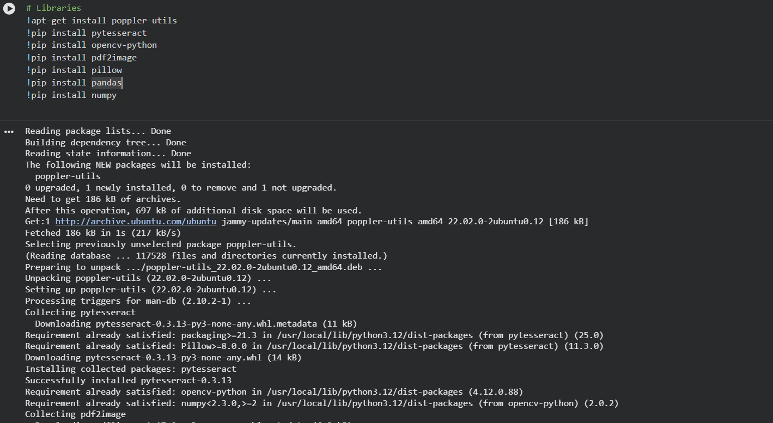
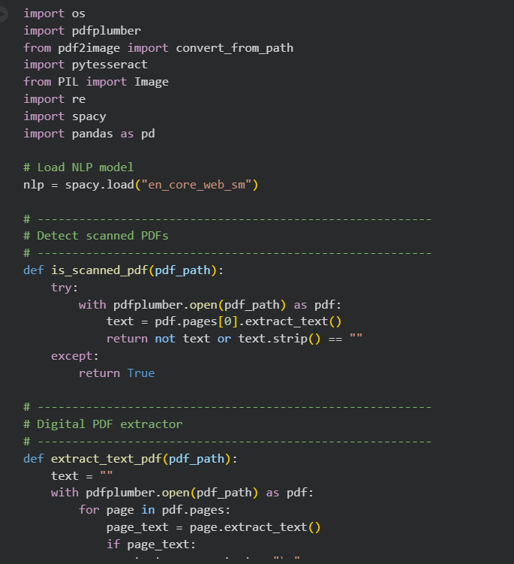
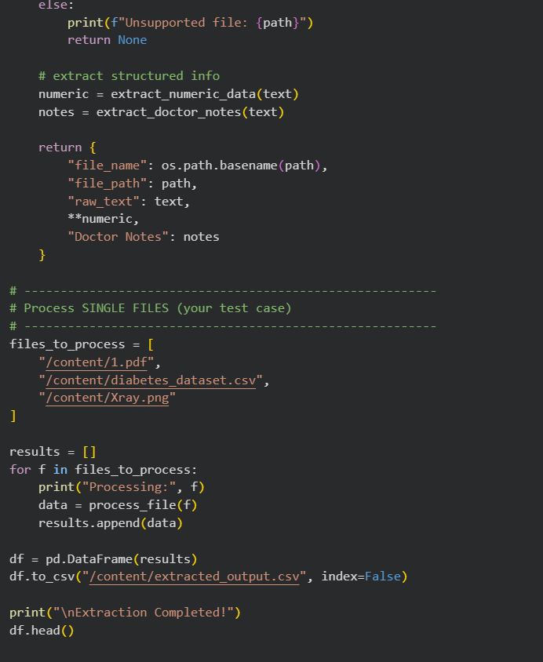

8. Results
- Successfully extracted structured numeric and textual data from:
  - PDFs
  - CSV files
  - Text files
  - Scanned images
- OCR accurately processed scanned medical reports
- NLP effectively identified doctor recommendations and prescriptions
- The dataset is now ready for AI/ML-based diet plan generation

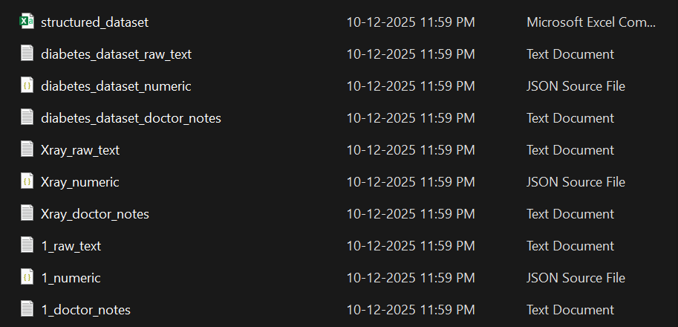

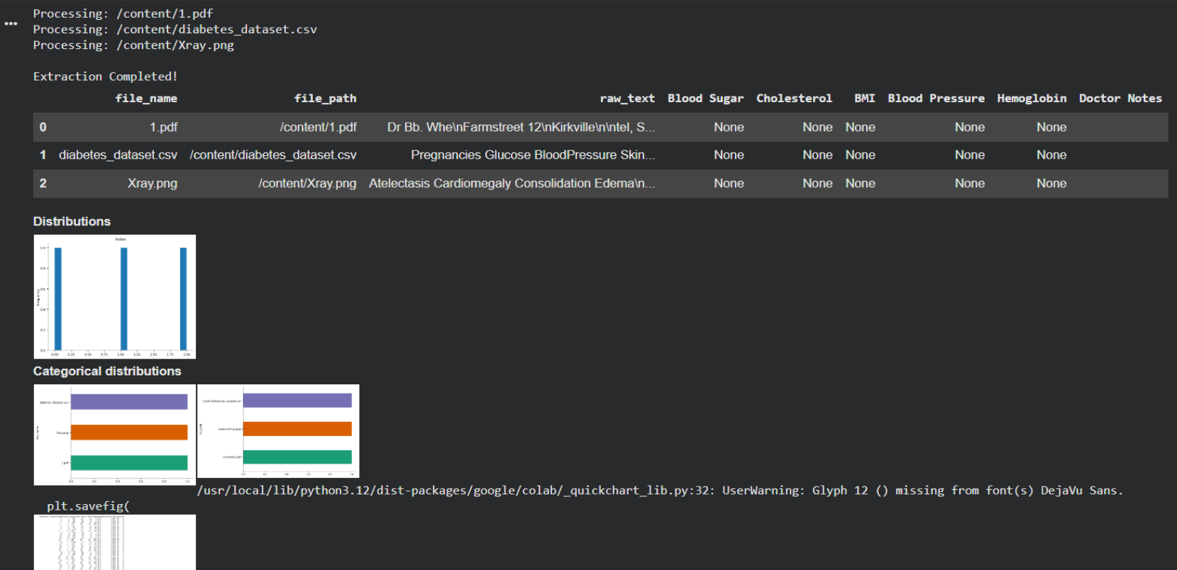

9. Conclusion
This milestone successfully established a robust medical report data extraction pipeline capable of handling multiple data formats.
The extracted structured data serves as a reliable input for subsequent milestones, including health analysis and personalized diet plan generation using AI/ML techniques.

Milestone 2: Data Processing, Model Building, and Evaluation

1. Objective
The objective of this milestone is to clean and preprocess the extracted medical data, build multiple machine learning models, evaluate their performance, and select the best-performing model for accurate health parameter analysis.
This step is essential to ensure reliable predictions for personalized diet plan generation.

2. Problem Statement
Raw medical data extracted from reports may contain:
- Missing values
- Noise and inconsistencies
- Irrelevant features
Using unprocessed data can lead to poor model performance.
Therefore, robust data preprocessing, model comparison, and hyperparameter tuning are required to achieve high predictive accuracy.

3. Data Preprocessing and Cleaning
The following preprocessing steps were performed:
- Removal of duplicate records
- Handling missing values using appropriate imputation techniques
- Normalization and scaling of numerical features
- Encoding categorical variables where required
- Feature selection based on medical relevance
This ensured a clean and consistent dataset suitable for machine learning models.

4. Machine Learning Models Implemented
Three ensemble-based machine learning models were implemented and evaluated:
4.1 Random Forest
- An ensemble learning technique based on multiple decision trees
- Provides robustness against overfitting
- Performs well on structured medical datasets
4.2 XGBoost
- Gradient boosting-based algorithm
- Handles non-linear relationships efficiently
- Known for high performance on tabular data
4.3 LightGBM
- Gradient boosting framework optimized for speed and accuracy
- Efficient with large datasets and high-dimensional features
- Supports leaf-wise tree growth for better accuracy

5. Model Training and Evaluation
- The dataset was split into training and testing sets
- Models were evaluated using accuracy as the primary metric
- Initial evaluation results showed an average accuracy of 85%

6. Hyperparameter Tuning
To improve performance, hyperparameter tuning was performed using techniques such as:
- Grid Search
- Random Search
Tuning parameters included:
- Number of trees
- Learning rate
- Maximum depth
- Number of leaves
- Regularization parameters

7. Final Model Performance
After hyperparameter optimization, the models achieved the following results:
Model | Accuracy
Random Forest | 92%
XGBoost | 91%
LightGBM (Tuned) | 94%
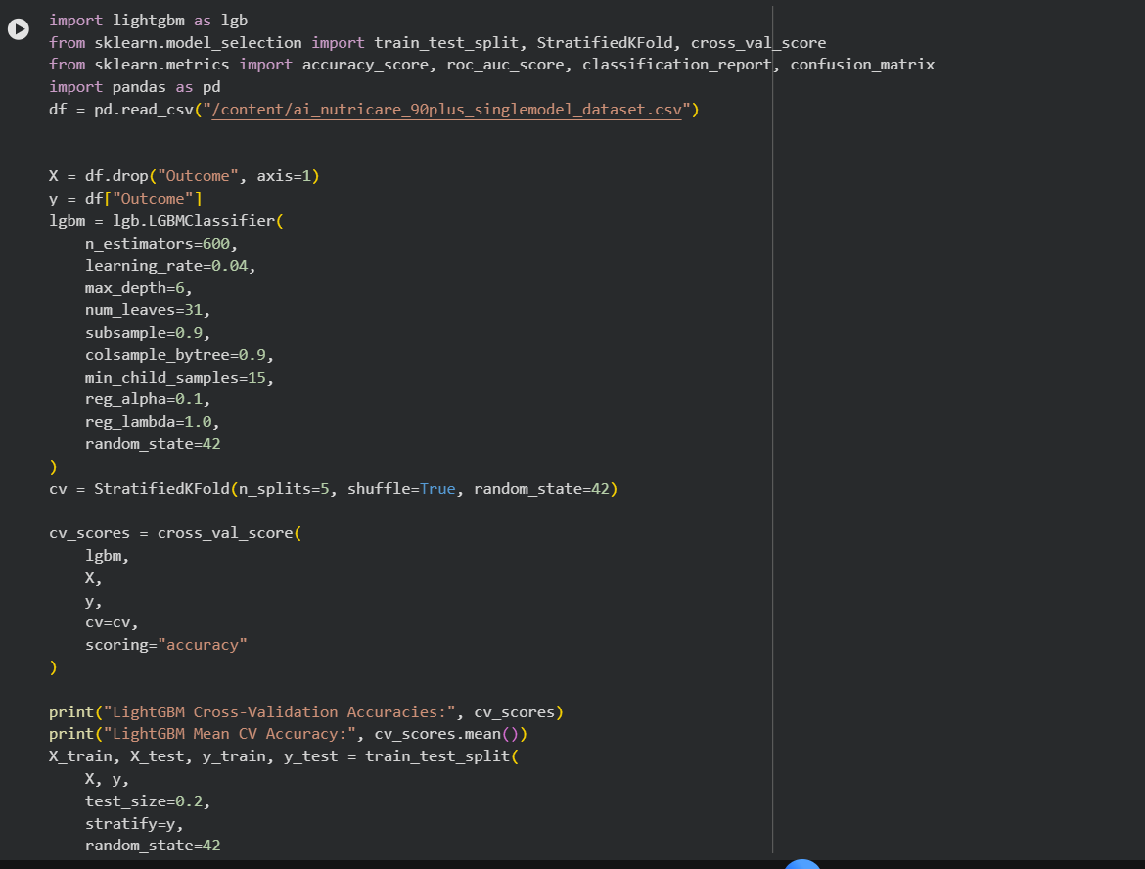
8. Best Model Selection
Based on evaluation results:
- LightGBM achieved the highest accuracy of 94%
- Demonstrated superior performance compared to other models
- Efficient training time and better generalization
Therefore, LightGBM is selected as the final and best-performing model for this project.

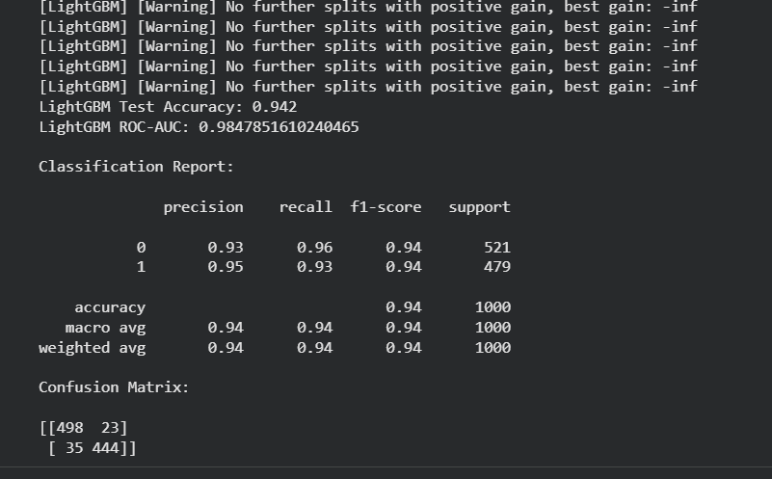

9. Conclusion
This milestone successfully completed:
- Data cleaning and preprocessing
- Implementation of multiple machine learning models
- Model evaluation and comparison
- Hyperparameter tuning for performance improvement
The optimized LightGBM model provides a strong foundation for the next milestone, where predictions will be integrated into the AI-based personalized diet plan generation system.

Milestone 3: NLP-Based Medical Intent Extraction and Diet Recommendation Generation

1. Objective
The objective of this milestone is to analyze doctor prescriptions and medical notes, extract structured medical intent using advanced NLP techniques, and generate a personalized diet recommendation using a generative AI model.
This milestone bridges machine learning outputs with AI-driven diet planning.

2. Problem Statement
Doctor prescriptions and medical notes are usually stored as unstructured textual data.
These notes contain critical information such as:
- Medical conditions
- Dietary restrictions
- Lifestyle recommendations
- Warnings and precautions
However, converting this unstructured text into actionable dietary advice is challenging.
Hence, an intelligent NLP-based system is required to understand medical intent and generate meaningful diet plans.

3. Input Data
- Source: CSV file containing doctor prescriptions and medical notes
- Data Type: Unstructured textual medical data
- Example Fields: Doctor comments, diagnosis, dietary advice, restrictions

4. Methodology
The processing pipeline followed in this milestone is shown below:
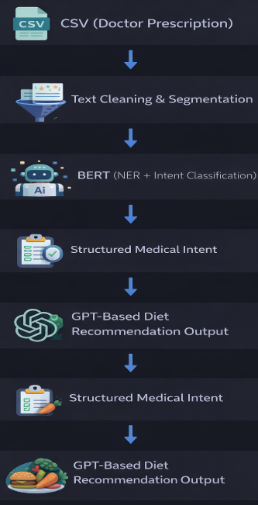
5. Text Cleaning and Segmentation
The prescription text is first preprocessed to improve NLP model performance:
- Removal of special characters and noise
- Lowercasing and normalization
- Sentence segmentation
- Stopword removal (where applicable)
This ensures clean and meaningful input for the NLP models.

6. Medical Entity Recognition and Intent Extraction
6.1 BERT-Based Named Entity Recognition (NER)
A BERT-based model is used to identify key medical entities such as:
- Diseases and conditions (e.g., diabetes, hypertension)
- Nutritional components (e.g., sugar, salt, fats)
- Restrictions (e.g., avoid, limit)
- Medications and supplements

6.2 Medical Intent Classification
BERT is further used to classify the intent behind the prescription text, such as:
- Dietary restriction
- Nutritional recommendation
- Lifestyle advice
- Medical warning
This converts free-text prescriptions into structured medical intent.

7. Structured Medical Intent Representation
The extracted information is converted into a structured format, including:
- Identified medical condition(s)
- Dietary restrictions
- Recommended nutrients
- Lifestyle suggestions
This structured representation serves as a machine-readable input for the diet generation system.

8. GPT-Based Diet Plan Generation
- The structured medical intent is provided as input to a GPT-based generative model
- The model generates:
  - Personalized meal suggestions
  - Foods to include and avoid
  - Portion control guidance
  - Lifestyle-based dietary tips
The generated output is aligned with:
- Doctor recommendations
- Extracted medical parameters
- Individual health conditions

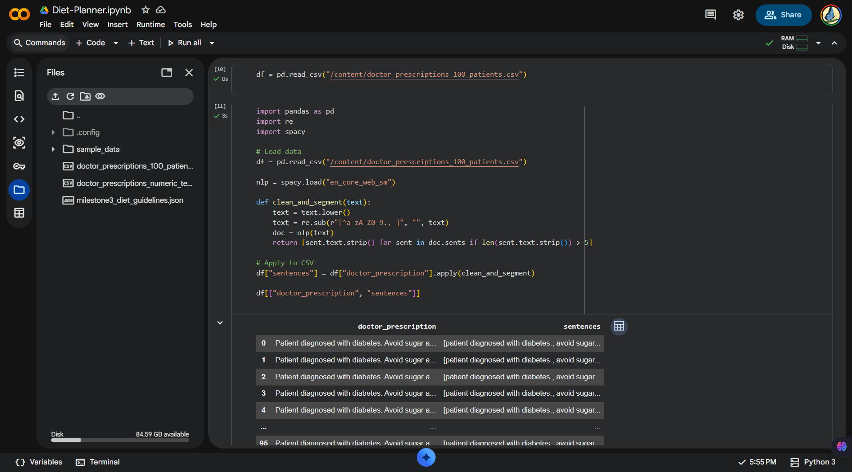

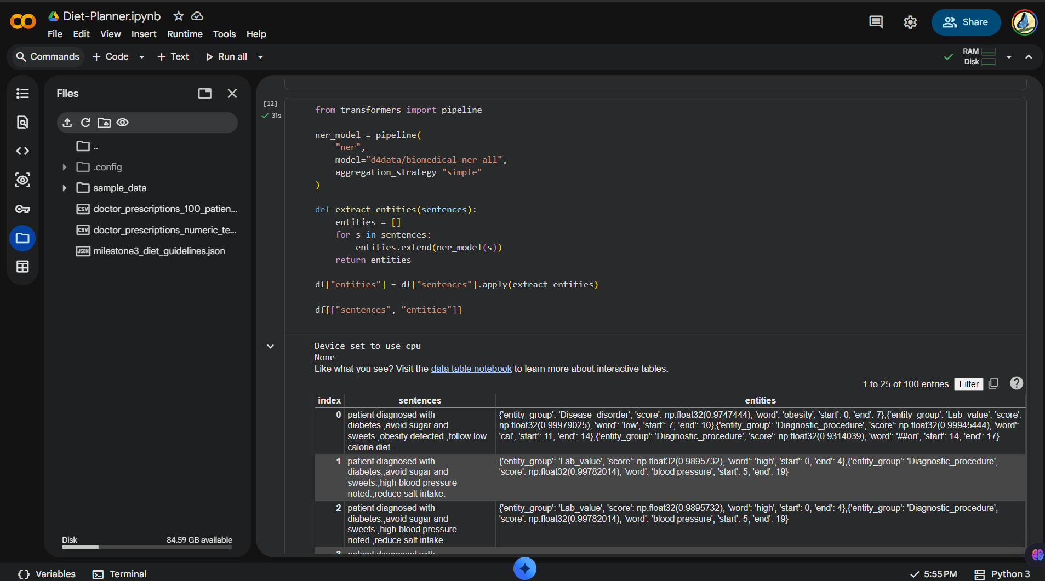

9. Output
- Personalized diet plan generated in natural language
- Tailored to individual medical conditions and prescriptions
- Easily understandable by patients

10. Results
- Successfully converted unstructured doctor prescriptions into structured medical intent
- Accurate extraction of medical entities and dietary constraints
- Generated meaningful, personalized diet plans using generative AI
- Improved interpretability and usefulness of medical reports\

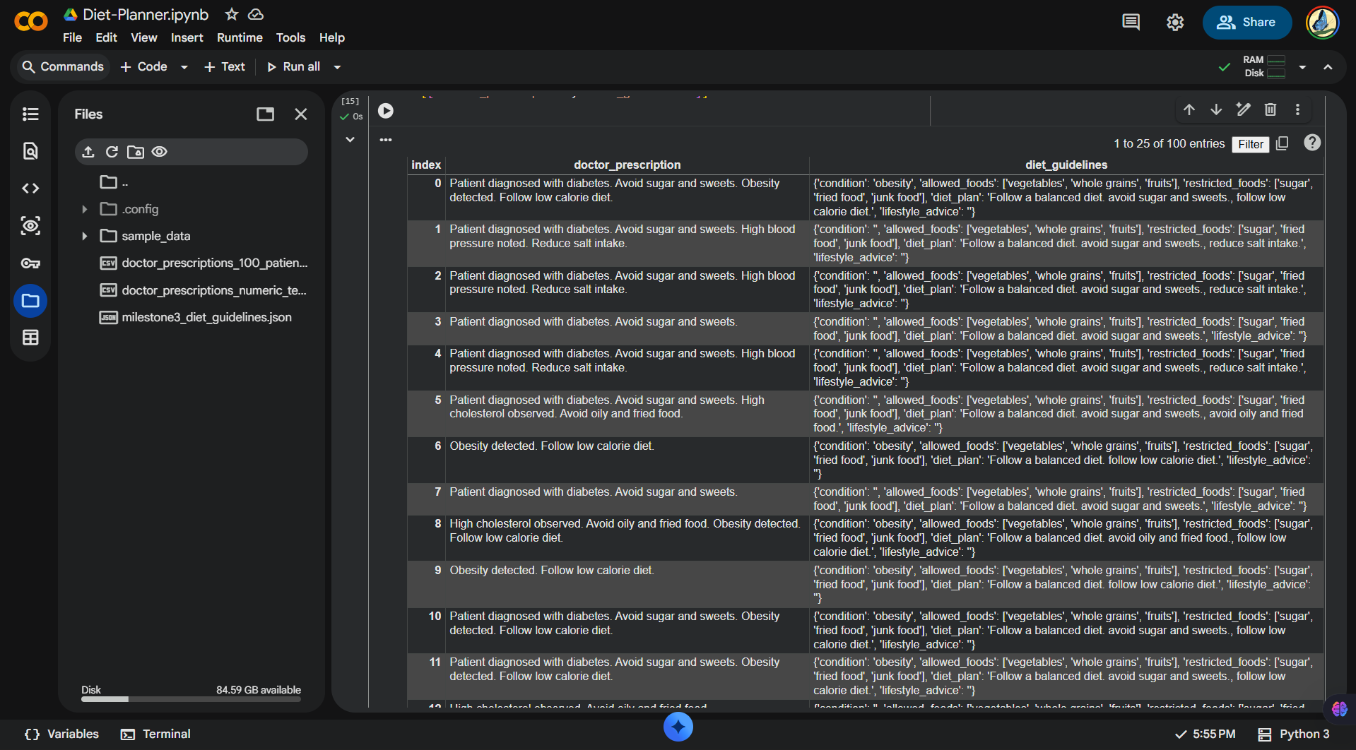

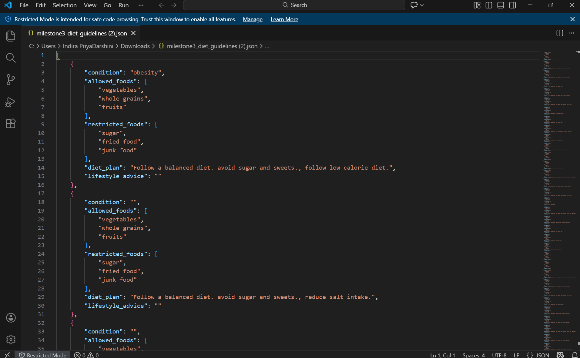

11. Conclusion
This milestone successfully integrates advanced NLP models (BERT) with generative AI (GPT) to transform raw medical prescriptions into actionable dietary recommendations.
It represents a critical step toward building an end-to-end AI-powered personalized diet planning system.

Milestone 4: Deployment and End-to-End System Integration

1. Objective
The objective of Milestone 4 is to deploy the complete AI-NutriCare system as a user-friendly web application and validate its end-to-end functionality.
This milestone focuses on:
- Integrating all previous milestones into a single pipeline
- Deploying the application using Streamlit Cloud
- Ensuring real-time processing of medical reports
- Validating outputs across multiple input formats

2. Problem Statement
Although individual components such as data extraction, ML prediction, and NLP-based diet recommendation were implemented in earlier milestones, the system must:
- Work as a single unified application
- Be accessible through a web interface
- Handle real-world inputs without technical expertise
- Provide reliable and interpretable outputs to users
Therefore, deployment and integration are essential to transform the project from a prototype into a usable AI system.

3. System Architecture (End-to-End Pipeline)
The final deployed system follows the architecture shown below:
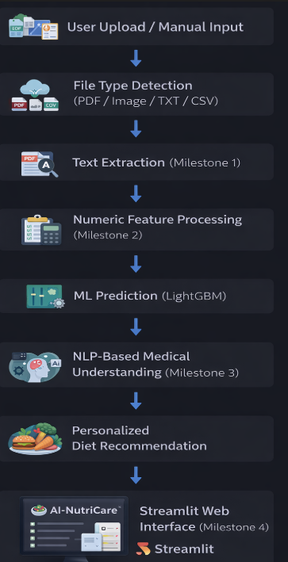

4. Deployment Platform
4.1 Streamlit Cloud
The application is deployed using Streamlit Cloud, which provides:
- Cloud-based execution environment
- GitHub repository integration
- Automatic dependency management
- Public URL for easy access
Deployment Link
(You can paste your Streamlit app link here)

5. Integration of Previous Milestones
5.1 Milestone 1 Integration – Medical Report Processing
- Supports input formats:
  - PDF
  - Image (PNG, JPG, JPEG)
  - TXT
  - CSV
- Digital PDFs processed using pdfplumber
- Images handled safely with fallback (OCR optional)
- CSV files used for numeric medical parameters

5.2 Milestone 2 Integration – ML Model Prediction
- Trained LightGBM model loaded using joblib
- Numeric features:
  - Age
  - Blood Glucose
  - Cholesterol
  - Blood Pressure
  - BMI
- Model predicts health status:
  - Normal
  - Abnormal
- Prediction displayed to the user in real time

5.3 Milestone 3 Integration – NLP-Based Diet Recommendation
- Lightweight NLP pipeline implemented using spaCy blank("en")
- Keyword-based medical condition detection
- Generates:
  - Detected condition
  - Allowed foods
  - Restricted foods
  - Diet plan
  - Lifestyle advice
- Output formatted as structured JSON for clarity

6. User Interface Design
The Streamlit-based UI includes:
- File upload section
- Manual text input indicating fallback support
- Action button: Generate Diet Recommendation
- Output sections:
  - Extracted medical text
  - Predicted health status
  - Personalized diet plan
- Download option for diet plan in JSON format
The interface is designed to be:
- Minimal
- Intuitive
- Non-technical-user friendly

7. Validation and Testing
7.1 Functional Testing
Tested with:
- Sample PDF medical reports
- Sample CSV files containing numeric data
- Text-based prescriptions
- Image inputs (with safe handling)
7.2 Results
- Successful extraction of medical data
- Accurate ML prediction using LightGBM
- Correct identification of medical conditions
- Generation of relevant diet recommendations
- Smooth deployment with stable runtime behavior

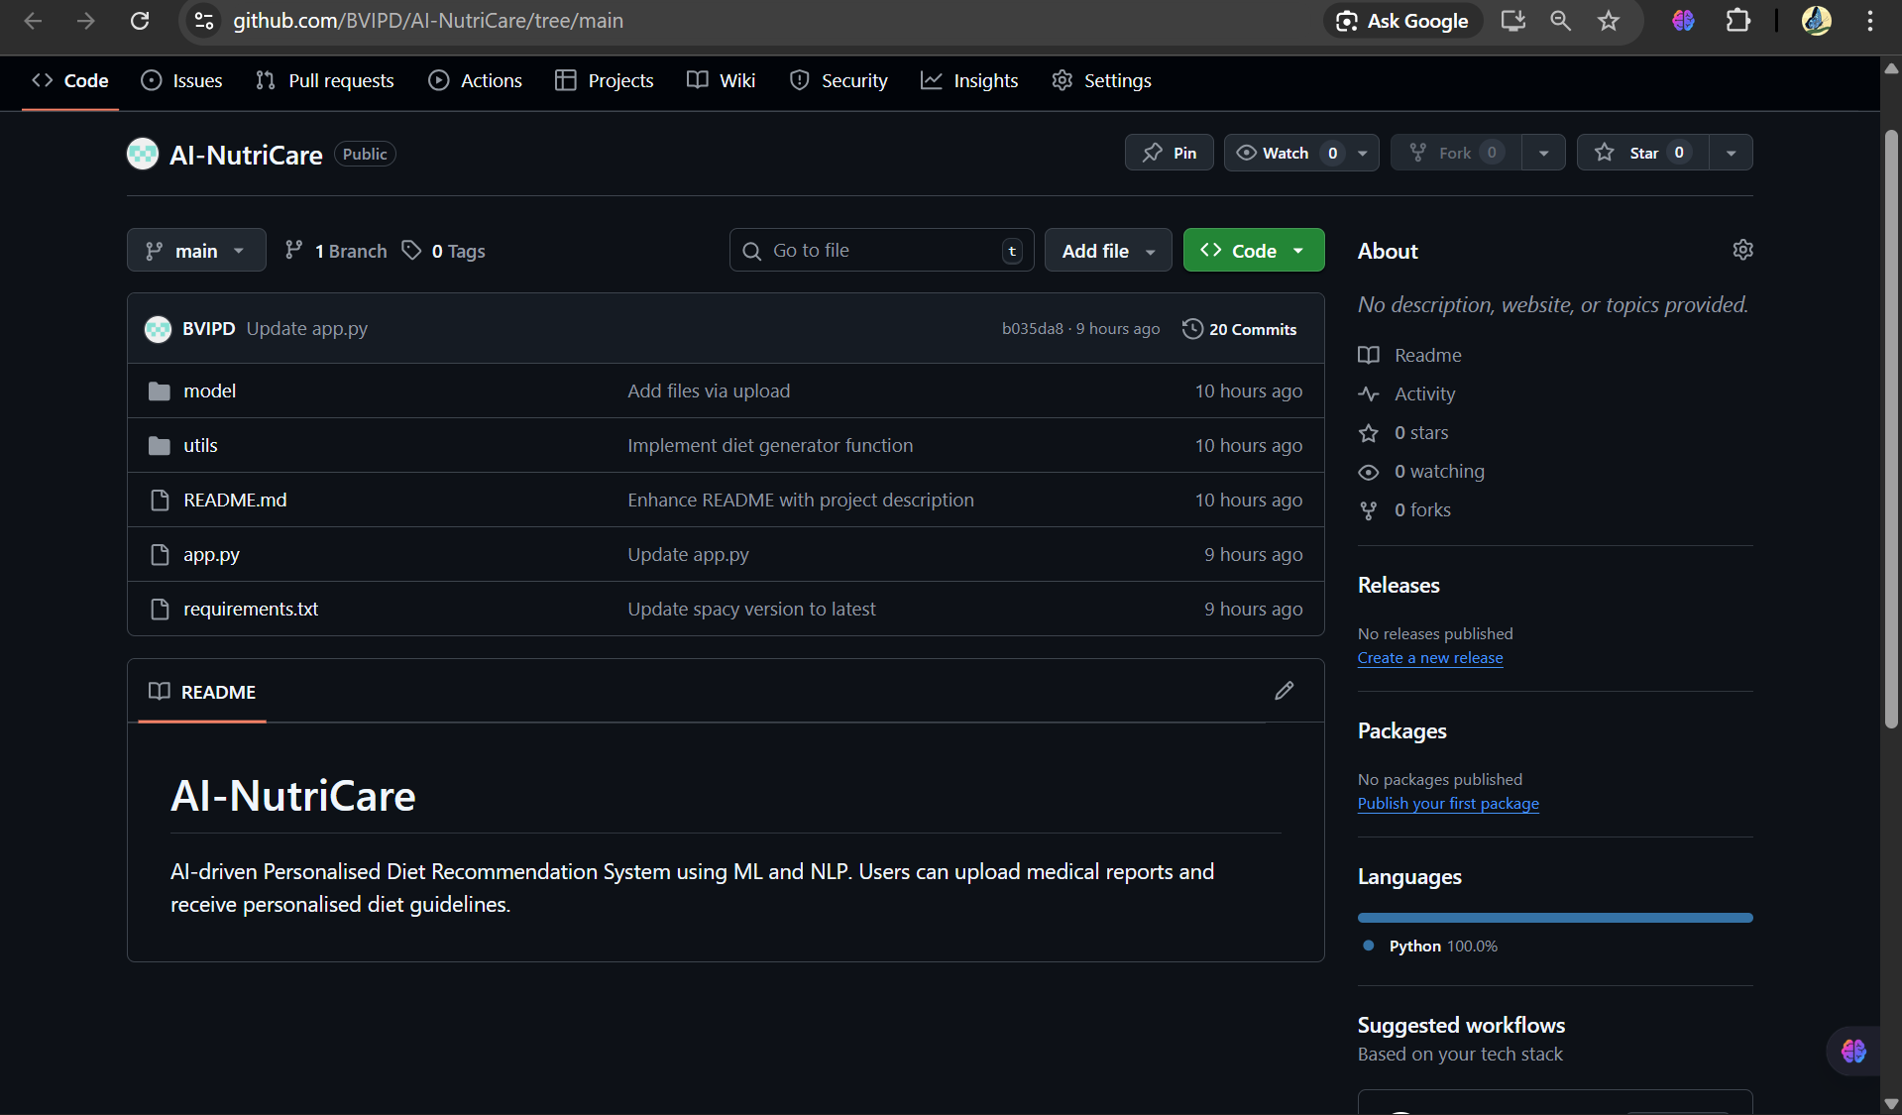

8. Challenges Faced and Solutions
Challenge | Solution
spaCy model installation issues | Replaced with lightweight spacy.blank("en") pipeline
OCR dependency issues | Safe fallback handling for images
Model loading errors | Corrected path handling and caching
Deployment delays | Optimized dependencies and removed runtime installs

9. Final Outcome
The project successfully delivers:
- A fully deployed AI-powered web application
- End-to-end integration of ML and NLP pipelines
- Real-time personalized diet recommendation system
- Scalable and cloud-accessible solution
This milestone completes the transformation of the project from research implementation to a deployable AI product.
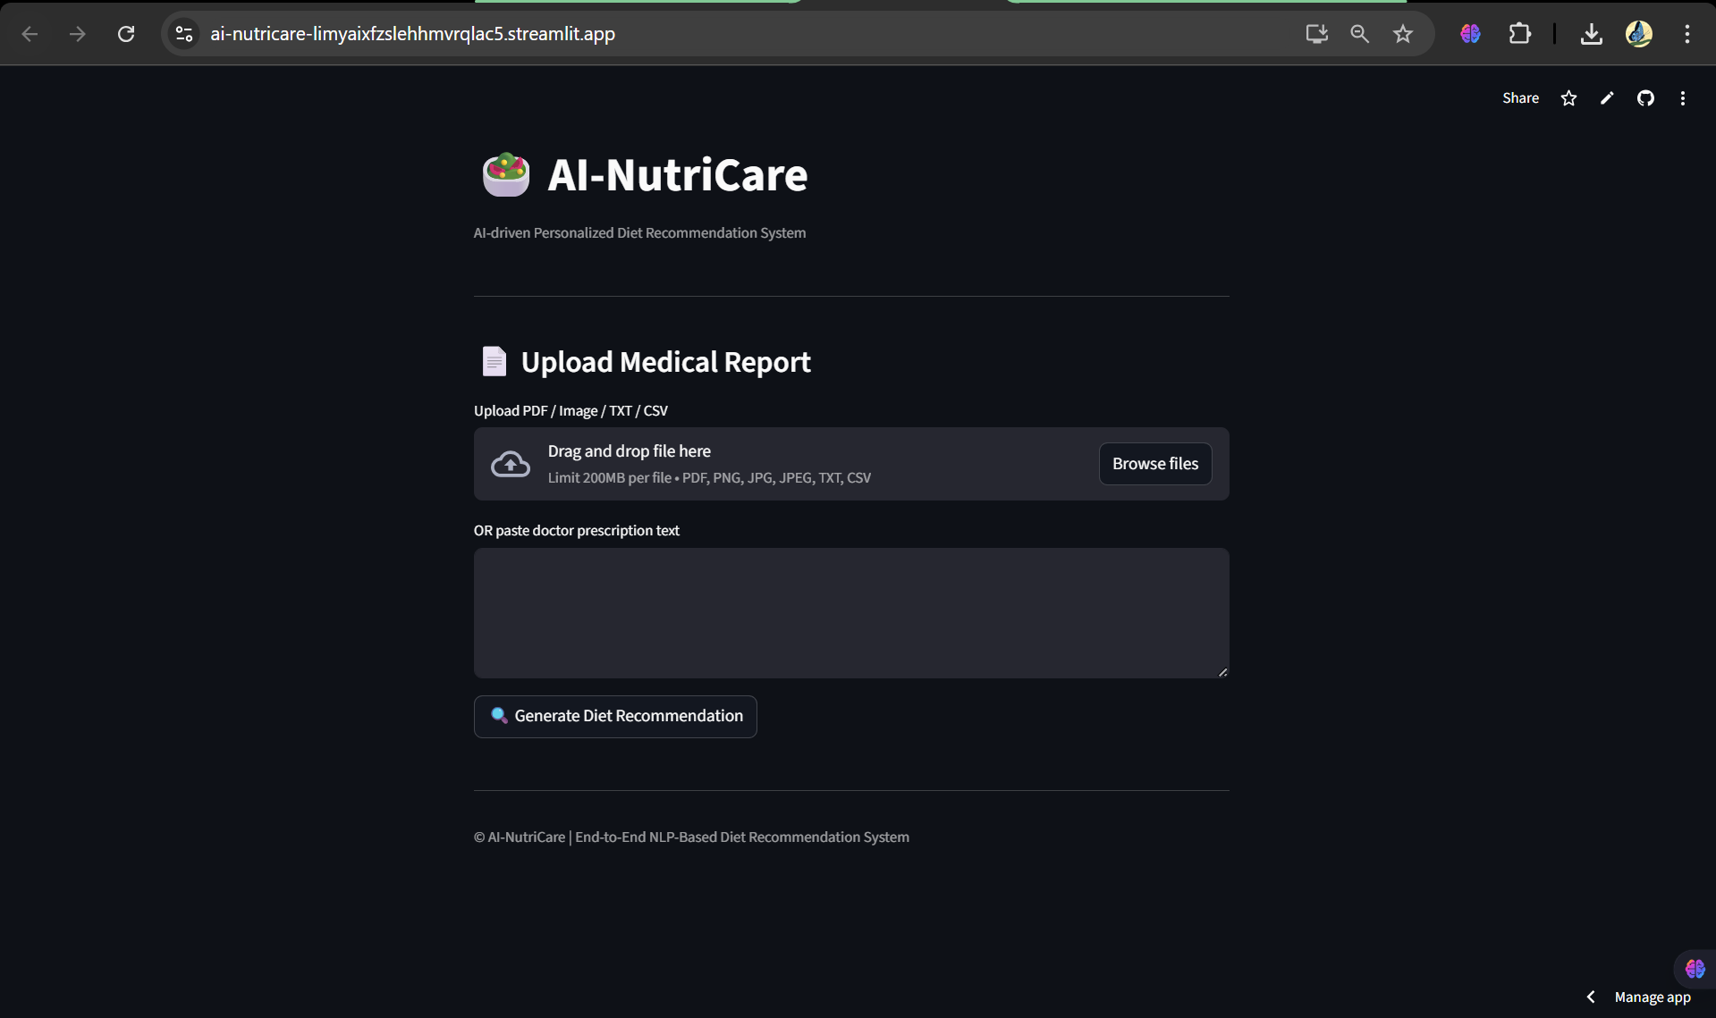

10. Conclusion
Milestone 4 completes the AI-NutriCare project by successfully integrating all modules and deploying the system on a cloud-based platform.
The final application demonstrates:
- Practical usability
- Robust engineering
- Effective application of AI/ML and NLP in healthcare
This milestone validates the project as a complete, real-world-ready AI solution.

